Day 2 Take-Home Assignment
Model tiers, embeddings and verification
Participant: Gowtham | Repository: automation-to-agentic-spectrum | Runs performed: 31 October 2026
Data rule: only synthetic text was used (the lab's fictional contract, the lab sentences, and my own fictional IT service-desk policy). No .env file, API key or .venv folder is part of this submission.

Summary of what I changed
File | Change
verify_outputs.py | New item late_interest_percent_per_month (clause 4.2, 1.5%) in EXTRACT_SYSTEM, ground_truth(), NUMBER_IN_QUOTE and the offline reply. Fixed _number_variants() so a decimal such as 1.5 is no longer also matched as "2". New completeness check clause_coverage() (Part D question).
data/sentences.json | 8 synthetic sentences on a fifth topic, finance_expenses
embeddings_map.py | Bug fix: the map palette had only 4 colours, so zip() silently left the fifth topic off the plot. Added more colours.
tests/test_day2.py | 8 new tests: 5 for Part D (correct = LOW, invented quote = HIGH, decimal matching, missing clause) and 3 for Part C (new topic, toy limitation, real-model synonym test that is skipped when the model is unavailable)
data/my_query_itdesk.txt | My own synthetic source text for Part B
Unit tests: all 80 pass (1 skipped where the real embedding model is not installed). Before my changes the suite had 72 tests (Day 1 included).

Part A - Tier study
I ran compare_tiers_cli.py --query Q1, Q2 and Q3 (Claude Code CLI, one turn, no tools) on opus, sonnet and haiku. I judged correctness myself against the reference answers, and counted words for the length limits. The automatic check only looks for 620 and 24,800 on Q1.
Correctness scale (0-3). Q1: one point per sub-question correct. Q2: 3 = accurate and complete, minus 1 for anything not in the source. Q3: one point per valid risk, with the safer alternative required for 3.
Query | Tier | Correct? (0-3) | Seconds | Cost ($) | Followed length limit? | Notes
Q1 | opus | 3 | 4.3 | 0.0314 | Yes (123 / 150 words) | 620.00, 24,800.00, No + exact clause 11.4 quote. Checked the 20% cap. Most expensive.
Q1 | sonnet | 3 | 3.2 | 0.0118 | Yes (136 / 150) | All correct. Added an unneeded, slightly muddled remark about the 90-day notice period.
Q1 | haiku | 3 | 3.8 | 0.0009 | Yes (107 / 150) | All correct, clear working (1.8 -> 1 full step). 35x cheaper than opus. Used 822 output tokens for 107 words.
Q2 | opus | 3 | 2.5 | 0.0258 | Yes (2 sentences) | Covers all five clauses; says the extract names no currency.
Q2 | sonnet | 3 | 2.0 | 0.0123 | Yes (2 sentences) | Accurate; adds the derived 24,800 (correct).
Q2 | haiku | 2 | 1.3 | 0.0008 | Yes (2 sentences) | INVENTED a currency ("€12,400"). The source has no currency. A hallucination an executive would not notice.
Q3 | opus | 3 | 2.9 | 0.0236 | No (91 / 80 words) | Three valid risks (legal, retention/training, loss of control) + approved enterprise tool / anonymise.
Q3 | sonnet | 3 | 3.1 | 0.0114 | No (87 / 80) | Same quality as opus at under half the cost.
Q3 | haiku | 3 | 2.0 | 0.0006 | No (131 / 80) | Good content but 64% over the limit, the worst length control.
Note on "served by": for the opus runs the CLI reported claude-haiku-5-5 as well as claude-opus-5-5. Claude Code makes a small helper call on Haiku, so the opus cost includes that call. Each figure comes from a single run, so it is evidence, not proof.

Recommendation per task type
Task type | Tier | Evidence
Careful reading + arithmetic (Q1 contract figures) | Sonnet by default; trial Haiku | All three tiers scored 3/3 within the limit, so Opus's extra cost (0.0314 vs 0.0118 vs 0.0009) bought nothing here. For production I would run Sonnet through the Part D verification pipeline. Because code re-checks every number and quote, Haiku (35x cheaper than Opus) is a strong candidate once a larger test set confirms it. Opus only for unusual or ambiguous clauses.
Summarisation for people (Q2) | Sonnet | Haiku added a currency that is not in the document, the most dangerous error in this study because it looks plausible and nothing checks it. Sonnet was fully accurate at half Opus's price.
Short judgement / advice (Q3) | Sonnet (Haiku with a length check) | Content was equally good on all tiers, so Opus is not worth 2x. No tier respected the 80-word limit. If length matters, enforce it in code (count words, retry or trim) instead of trusting the prompt.

Part B - Own query across six tools

1. My query (synthetic, work-relevant)
I wrote a fictional IT service-desk policy extract (144 words: priorities, targets, password-reset rule, escalation) and three questions with known answers. I included a contact e-mail and phone number on purpose, to test the redaction step.
You are helping an IT service desk analyst. Using ONLY the policy below, answer:
1. The payroll team (12 people) cannot open the payroll system at all; everyone else can work. Which priority is this, and within what time must it be resolved?
2. A manager phones and asks the desk to reset the password of a team member who is on leave. What must the desk do? Quote the clause.
3. A P3 ticket was logged on Monday at 10:00 and is still open on Wednesday at 10:00. Must it be escalated to the Duty Manager under clause 5.1?
Keep the answer under 120 words.

<policy>
IT SERVICE DESK POLICY - EXTRACT (fictional, for training use)

2.1 Priorities. P1: a whole site or a critical system is down. P2: one team is blocked. P3: one user is affected and has a workaround. P4: a request or question.

2.2 Targets. P1: respond within 15 minutes, resolve within 4 hours. P2: respond within 1 hour, resolve within 8 business hours. P3: respond within 4 business hours, resolve within 3 business days. P4: resolve within 5 business days.

3.4 Password resets. The service desk may reset a password only after verifying the caller with a one-time code sent to the phone number already on file. A reset requested by a third party on behalf of a colleague must be refused and logged.

5.1 Escalation. A P2 ticket not resolved within its target is escalated to the Duty Manager ([EMAIL], [PHONE]).
</policy>
Redaction (redact_pii.py --file): FOUND {EMAIL: 1, PHONE: 1}. Both were replaced with [EMAIL] and [PHONE] before the text was sent. "Duty Manager" is a role, not a name. The tool would not have caught a person's name, so I read the text myself before sending.
Reference answers. (1) P2, because one team is blocked; resolve within 8 business hours. (2) Refuse and log, clause 3.4: "A reset requested by a third party on behalf of a colleague must be refused and logged." (3) No: 5.1 applies only to P2 tickets, and the P3 target of 3 business days has not been reached. Question 3 is a deliberate trap.

2. Three Claude tiers (compare_tiers_cli.py --prompt)
Tier | Correct? (0-3) | Seconds | Cost ($) | Under 120 words? | Notes
opus | 3 | 4.0 | 0.0258 | Yes (103) | Correct, and flagged that "critical system" is undefined. Avoided the trap: 5.1 covers only P2.
sonnet | 3 | 2.7 | 0.0113 | No (126) | Correct, including the trap; slightly over the limit.
haiku | 3 | 3.7 | 0.0009 | No (125) | Correct and useful (gave P1 targets if payroll counts as critical); over the limit.
All three tiers handled the trap question. Again the difference was cost and length control, not correctness.

3-5. Consumer apps (ChatGPT, Claude.ai, Gemini) with the lab Q1 prompt
TO COMPLETE: Gowtham runs the identical Q1 prompt (homework_pack.py) in a NEW chat in each app, records model/plan, time and answer, and finds the data-training setting. Claude then fills this table and outputs/homework_comparison.md. The steps are in PartB_Your_Steps.txt.
Question | ChatGPT | Claude.ai | Gemini
Model / plan shown in the app
Credit amount correct (620.00)?
Termination charge correct (24,800)?
Quoted clause 11.4 for the data question?
Stayed under 150 words?
Time to answer (s, roughly)
Added anything NOT in the clauses?
Where is the "use chats to improve the model" setting; default?
Account type (personal / enterprise)

Trust analysis (8-12 sentences)
TO COMPLETE: written after the consumer-app answers are in, so the analysis is based on what each tool actually did.

Part C - Embeddings experiment

1. New topic: finance_expenses (8 synthetic sentences)
Where do I upload hotel receipts from last week's business trip?
My expense claim for the conference dinner was rejected by finance.
What is the daily meal allowance when travelling for work?
Can I submit mileage for driving my own car to the client site?
When is the deadline to file this month's travel expenses?
Does the company cover the cost of a visa for an overseas assignment?
My manager has not approved my expense report yet.
Which cost centre code should I use for the training course fee?

2. Toy map vs real model
Toy embedder (--toy), run done. The four original topics form tight clusters. The eight finance_expenses points are scattered across the middle of the map, and one of them ("My manager has not approved my expense report yet") sits inside the hr_leave cluster. While doing this I found a bug: with five topics, the 4-colour palette made zip() silently drop the fifth topic from the plot. I added more colours.
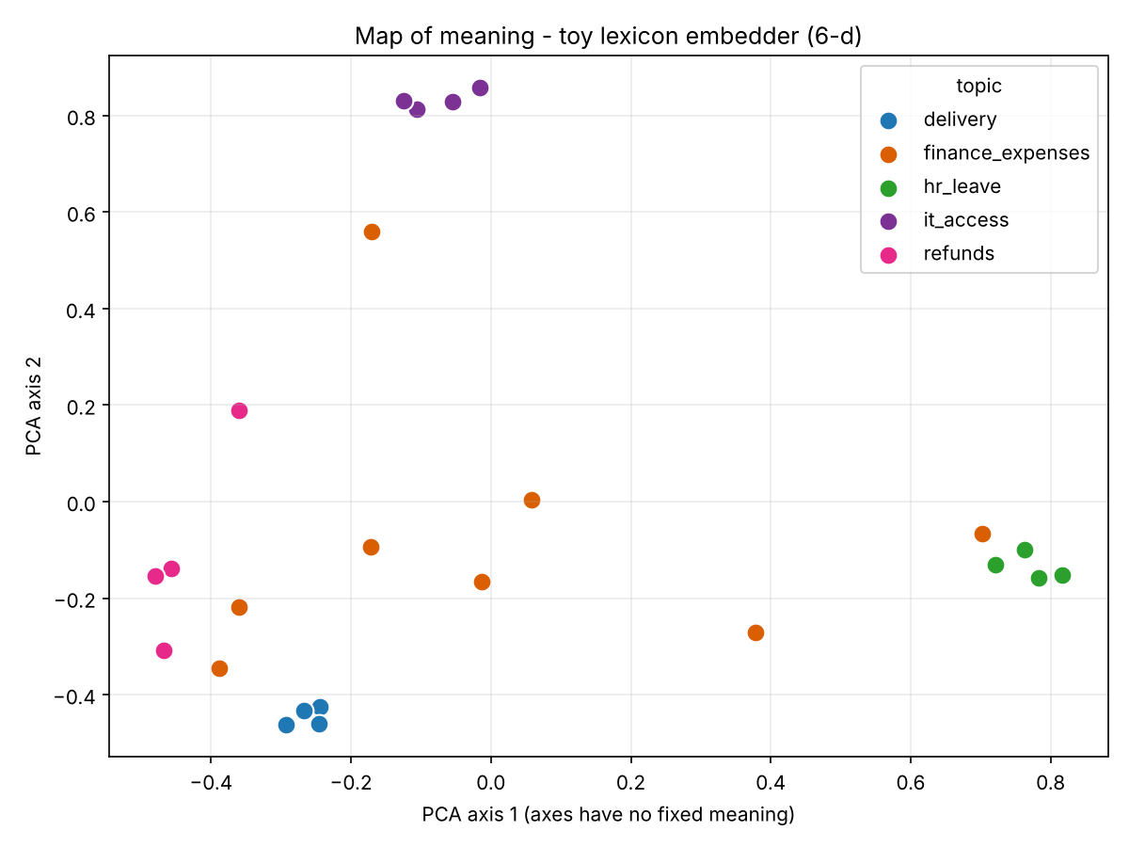
Real model (fastembed bge-small, 384-d). I installed fastembed, but the model download (Hugging Face) was blocked in the cloud workspace where I ran the experiments, so I could not run it there. Expected result, to be confirmed: finance_expenses forms its own cluster close to refunds, because both are about money, but separate from it.
TO COMPLETE: Gowtham runs `pip install -r requirements-embeddings.txt` and `python solutions/day2_models_and_embeddings/embeddings_map.py` on his machine and pastes the output; this paragraph and the comparison are then updated with the real result.

3. A query where the toy embedder fails
Toy embedder probe - Part C (dimensions: money, delivery, damage, access, leave, security)

QUERY: Can I expense a hotel booking?
query vector: [0.33, 0.63, 0.63, 0.33, 0.03, 0.03]
sim=0.81 [refunds] I would like my money returned because the item arrived broken.
sim=0.73 [delivery] The courier left the package at the wrong address.
sim=0.71 [delivery] My parcel has not arrived and the tracking page shows no update.

QUERY: What is the per diem for a business trip?
query vector: [0.72, 0.25, 0.25, 0.25, 0.48, 0.25]
sim=0.99 [finance_expenses] Does the company cover the cost of a visa for an overseas assignment?
sim=0.92 [finance_expenses] Can I submit mileage for driving my own car to the client site?
sim=0.85 [finance_expenses] When is the deadline to file this month's travel expenses?

QUERY: How do I get reimbursed for my travel costs?
query vector: [0.51, 0.27, 0.51, 0.27, 0.27, 0.51]
sim=0.93 [finance_expenses] My expense claim for the conference dinner was rejected by finance.
sim=0.88 [finance_expenses] Does the company cover the cost of a visa for an overseas assignment?
sim=0.82 [finance_expenses] Can I submit mileage for driving my own car to the client site?

Vector of 'My manager has not approved my expense report yet.': [0.11, 0.01, 0.32, 0.11, 0.88, 0.32] (leave dimension dominates because 'manager' is in the leave group)
Why (in terms of the six word-groups). The toy vector has one dimension per word group: money, delivery, damage, access, leave and security. None of "expense", "hotel" or "booking" is in any group, and "book" is in the leave group but only as an exact match, so "booking" does not count. Every word in "Can I expense a hotel booking?" is therefore unknown and adds only a 0.12 checksum "nudge" to an arbitrary dimension. The resulting vector (0.63 delivery, 0.63 damage) is noise, so the nearest neighbours are a refund and two delivery sentences. The same mechanism explains the misplaced point on the map: "manager" is in the leave group, so the expense-report sentence becomes mostly "leave" (0.88). The toy's apparent successes are not evidence of meaning either. "What is the per diem for a business trip?" found finance_expenses at 0.99 only because the shared filler words (what, is, the, for, a) produce the same checksum nudges. A real model learns from millions of examples that "expense", "receipt", "per diem" and "mileage" belong together, so it should succeed.

4. Tests added (tests/test_day2.py)
- test_new_topic_has_eight_sentences: the topic exists with 8 sentences.
- test_toy_embedder_cannot_find_expenses_by_synonym: a positive synonym test is NOT possible with the toy embedder, because it has no expenses dimension. Any hit would come from checksum coincidence. This test records that limitation.
- test_real_model_finds_expenses_by_synonym: "Can I expense a hotel booking?" must return finance_expenses in the top 3 with the real model. The test is skipped automatically where the model is unavailable.

5. What "distance" means, and why the axes have no fixed meaning
Each point is a whole sentence. The distance between two points shows how different their meanings are as the model sees them: close points have embedding vectors pointing in similar directions (high cosine similarity), far points have little in common. The map is not the real space: the toy has 6 dimensions and bge-small has 384, and PCA squeezes them into the 2 directions along which these particular sentences vary most. The axes are just those directions, a blend of many original dimensions, and they change whenever the set of sentences changes. Adding my fifth topic re-orients the whole picture. So "left" or "up" means nothing on its own; only relative closeness and clusters can be read, and even those are approximate because projecting to 2-D distorts some distances.

Part D - Extend the verification pipeline

1. New item: late-payment interest per month (clause 4.2, 1.5%)
EXTRACT_SYSTEM: late_interest_percent_per_month - interest rate per month on overdue invoices (percent)
ground_truth(): late_interest = 1.5 # clause 4.2 -> "late_interest_percent_per_month": 1.5
NUMBER_IN_QUOTE: {..., "late_interest_percent_per_month"} # 1.5 must appear in the quote
OFFLINE_REPLY: "late_interest_percent_per_month": {"value": 1.5, "quote": "Invoices unpaid after 30 days
incur interest at 1.5% per month on the overdue amount"}
Bug found and fixed: _number_variants(1.5) produced "1.50", "1.5" and also "2" (from rounding with :.0f). A quote containing "2%" would therefore have passed the number-in-quote check for 1.5. Now only whole numbers get the no-decimals variants.

2. Unit tests
Test | What it proves
test_late_interest_correct_is_low | Correct value 1.5 + real quote: item passes, number is in the quote, overall tier LOW
test_late_interest_invented_quote_is_high | Invented quote "interest at 2% per month...": quote_exists = False, tier HIGH
test_late_interest_ground_truth | Code's own truth is 1.5
test_decimal_rate_is_not_rounded_when_matching_quote | 1.5 no longer matches "2"
test_completeness_check_flags_a_silently_missing_clause | Remove the termination item: clause 9.2 is reported as uncovered

3. Results
--offline-demo
item model expected quote exists number in quote value ok
-------------------------------------------------------------------------------------------
monthly_fee 12400 12400 yes yes yes
credit_percent_per_step 5 5 yes yes yes
credit_cap_percent 25 20 NO yes NO
credit_for_98_6 1240 620 yes n/a NO
termination_charge_8m 24800 24800 yes n/a yes
late_interest_percent_per_month 1.5 1.5 yes yes yes

Completeness: required clauses ['4.1', '4.2', '7.1', '9.2']; not covered by any quote: none

RISK TIER: HIGH
-> Possible fabricated evidence. Do not use. A person must review the source.
Live mode (claude-sonnet-5-5)
item model expected quote exists number in quote value ok
-------------------------------------------------------------------------------------------
monthly_fee 12400.0 12400 yes yes yes
credit_percent_per_step 5 5 yes yes yes
credit_cap_percent 20 20 yes yes yes
credit_for_98_6 620.0 620 yes n/a yes
termination_charge_8m 24800.0 24800 yes n/a yes
late_interest_percent_per_month 1.5 1.5 yes yes yes

Completeness: required clauses ['4.1', '4.2', '7.1', '9.2']; not covered by any quote: none

RISK TIER: LOW
-> All checks passed. Normal practice: spot-check a sample.
Audit-log lines (outputs/verification_audit.jsonl)
{"time": "2026-10-31T14:36:01+00:00", "source": "offline-demo", "tier": "HIGH", "failed_items": ["credit_cap_percent", "credit_for_98_6"]}
{"time": "2026-10-31T14:36:06+00:00", "source": "claude-sonnet-5-5", "tier": "LOW", "failed_items": []}
The offline reply still shows its two deliberate errors (an invented 25% cap and a wrong 1,240 credit) and is HIGH risk. The new item passes in both runs. The live Sonnet extraction passed every check: LOW risk.

4. If the model had silently left out clause 9.2
In this script the per-item check would notice, but only because we explicitly asked for termination_charge_8m: a missing key fails. The real gap is wider. The checks only verify what the model returned. If the model wrote a summary or extraction that never mentioned clause 9.2, every quote would exist, every number would match, and the run would be LOW risk while a two-month termination charge was missing. Nothing checks completeness against the source.
Proposed and implemented check: clause coverage. A list of REQUIRED_CLAUSES (4.1, 4.2, 7.1, 9.2) is kept in code. clause_coverage() splits the contract into clauses by their numbers and confirms that each required clause is supported by at least one returned quote. Any uncovered clause raises the tier to MEDIUM with the message "Clause(s) ... not supported by any quote. A person must check nothing was left out." The test deletes the termination item and gets {"9.2"}. A further step for free-text summaries would be to ask the model for a per-clause checklist (clause -> covered yes/no + quote) and compare it with the clause numbers code extracts from the document.

Part E - Approved-tools guideline (DRAFT)
DRAFT for discussion. This guideline must be reviewed and confirmed by our organisation's security and legal teams before anyone relies on it. It is based on the lab's EXAMPLE data/approved_tools.json, not on our actual contracts.
Data class | Example | Claude Code with organisation key | Consumer chat (personal account) | Enterprise plan chat
Public | Published web page | Allowed. Already public; no confidentiality risk. | Allowed. Public text only; still check the output before reuse. | Allowed. No restriction beyond normal accuracy checks.
Internal | Meeting notes, no personal data | Allowed. Organisation-managed key under our agreement; follow the programme's usage rules. | Not allowed. Consumer terms may allow chats to be kept, reviewed or used for training, and we have no contract over the data. | Allowed, once security confirms the enterprise agreement covers internal data.
Confidential / personal | Customer names and order history | Ask security. The example policy says no customer personal data unless our data policy allows it; a data-processing agreement and lawful basis are needed. | Not allowed. Personal data in a personal account breaches data-protection duties (no DPA, no control, no deletion). | Ask security. It depends on the DPA, data location (e.g. EEA-only clauses) and classification; redact or pseudonymise first where possible.

Rules that apply to every tool
- Check which account you are signed in to (personal vs enterprise) before pasting anything; the same app can sit under very different data terms.
- Run redaction (redact_pii.py or equivalent) before sharing text, then read it yourself: pattern-based redaction does not catch names or free-text details.
- Never paste secrets: API keys, passwords, .env files, access tokens or internal URLs with credentials.
- In consumer tools, find the "use my chats to improve the model" setting and record its state; switching it off does not make a personal account suitable for internal or personal data.
- Treat every model answer as a proposal: numbers, quotes and legal statements must be verified (as in Part D) before anyone acts on them.
- When in doubt, choose "Ask security"; the safe default is not to paste.

Evidence files
Console output of every run is in docs/assignments/day2_submission/evidence/. The tier reports are outputs/tier_comparison_Q1.md, _Q2.md, _Q3.md and _custom.md, copied to docs/assignments/day2_submission/reports/ (git ignores the outputs/ folder).

